Q1: Process requests are given as;

**25 K , 50 K , 100 K , 75 K**

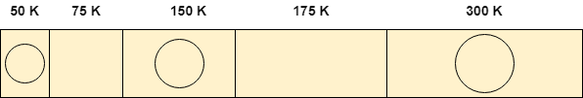

Determine the algorithm which can optimally satisfy this requirement.

1. First Fit algorithm
2. Best Fit Algorithm
3. Neither of the two
4. Both of them

In the question, there are five partitions in the memory. 3 partitions are having processes inside them and two partitions are holes.

Our task is to check the algorithm which can satisfy the request optimally.

Q2: consider five memory partitions of size 100 KB, 500 KB, 200 KB, 450 KB and 600 KB in same order. If sequence of requests for blocks of size 212 KB, 417 KB, 112 KB and 426 KB in same order come, then which of the following algorithm makes the efficient use of memory?  
  
A.Best fit algorithm  
  
B.First fit algorithm  
  
C.Next fit algorithm  
  
D.Both next fit and best fit results in same  
  
   
  
Please provide solution for above question

Q3: Suppose a fixed partitioning memory system with partitions of 100K, 500K, 200K, 300K, and 600K (in memory order) exists. All five partitions are currently available. Using the best fit algorithm, find how much**space**exists in this system after processes of 212K, 417K, 112K, and 350K (in request order) arrive.

:

Q4: Assume 140K, 260K, 60K memory is free. What is the total external fragmentation that arises for the following requests 110K, 30K, 210K, 50K using Best-fit policy,

A) 120K

B) 110K

C) 60K

D)30K

Q5: Consider five memory partitions of size 100 KB, 500 KB, 200 KB, 450 KB and 600 KB in same order. If sequence of requests for blocks of size 212 KB, 417 KB, 112 KB and 426 KB in same order come, then Specify the Working of how next fit algorithm allocation?